Five steps of encapsulation:
 | 1. User information is converted into data.  2. Data is converted into segments for transport across the network.  3. Segments are converted into packets and datagrams for transport across the network.  4. Packets and datagrams are converted into frames and the Data Link header is added.  5. The data in the frames is converted into bits for transmission over the physical media
  User Information into Data
  Data into Segments
  Segments into Packets
  Packets into Frames
  Frames to Bits

Encapsulation within 802.5:

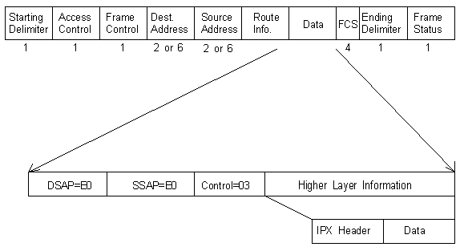
SSAP=source service access points
DSAP=destination service access points

Encapsulation within 802.3:

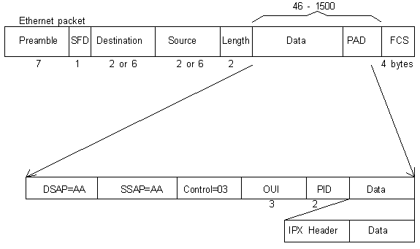

A MAC-Layer Bridge Connects the IEEE 802.3 and IEEE 802.5 Networks
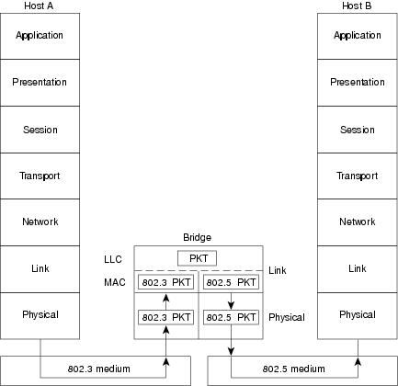

This illustrates an IEEE 802.3 host (Host A) formulating a packet that contains application information and encapsulating the packet in an IEEE 802.3-compatible frame for transit over the IEEE 802.3 medium to the bridge. At the bridge, the frame is stripped of its IEEE 802.3 header at the MAC sublayer of the link layer and is subsequently passed up to the LLC sublayer for further processing. After this processing, the packet is passed back down to an IEEE 802.5 implementation, which encapsulates the packet in an IEEE 802.5 header for transmission on the IEEE 802.5 network to the IEEE 802.5 host (Host B).
A bridge's translation between networks of different types is never perfect because one network likely will support certain frame fields and protocol functions not supported by the other network.

Figure 6-3 IEEE 802.5/Token Ring Frame Formats
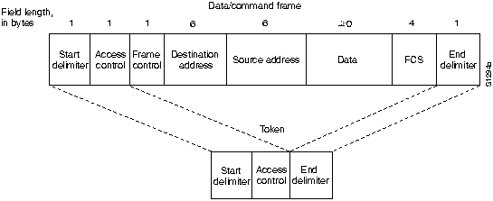

Figure 5-2 Ethernet and IEEE 802.3 Frame Formats
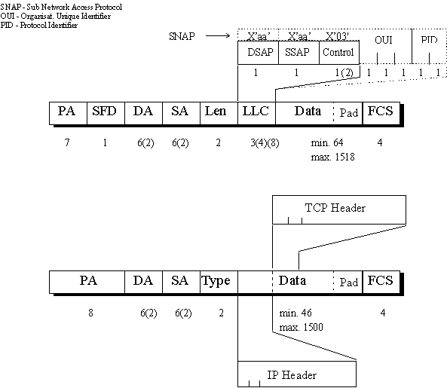
Preamble
Both Ethernet and IEEE 802.3 frames begin with an alternating pattern of (7 octetts of 1010....) ones and zeros called a preamble. The preamble tells receiving stations that a frame is coming.
Start of frame
The byte before the destination address in both an Ethernet and a IEEE 802.3 frame is a start-of-frame (SOF) delimiter (1 octett 10101011). This byte ends with two consecutive one bits, which serve to synchronize the frame reception portions of all stations on the LAN. Both preamble and start-of-frame (SOF) delimiter fields are handled in the physical layer.
Destination and source address fields
Immediately following the start-of-frame (SOF) delimiter in both Ethernet and IEEE 802.3 LANs are the destination and source address fields. Both Ethernet and IEEE 802.3 addresses are 6 bytes long. Addresses are contained in hardware on the Ethernet and IEEE 802.3 interface cards. The first 3 bytes of the addresses are specified by the IEEE on a vendor-dependent basis, while the last 3 bytes are specified by the Ethernet or IEEE 802.3 vendor. The source address is always a unicast (single node) address, while the destination address may be unicast, multicast (group), or broadcast (all nodes).
Type field
In Ethernet frames, the 2-byte field following the source address is a type field. This field specifies the upper-layer protocol to receive the data after Ethernet processing is complete.
Length field
In IEEE 802.3 frames, the 2-byte field following the source address is a length field, which indicates the number of bytes of data that follow this field and precede the frame check sequence (FCS) field.
Data
Following the type/length field is the actual data contained in the frame. After physical-layer and link-layer processing is complete, this data will eventually be sent to an upper-layer protocol. In the case of Ethernet, the upper-layer protocol is identified in the type field. In the case of IEEE 802.3, the upper-layer protocol must be defined within the data portion of the frame, if at all. If data in the frame is insufficient to fill the frame to its minimum 64-byte size, padding bytes are inserted to ensure at least a 64-byte frame.
FCS field
After the data field is a 4-byte FCS field containing a cyclic redundancy check (CRC) value. The CRC is created by the sending device and recalculated by the receiving device to check for damage that might have occurred to the frame in transit.
Summary
Preamble
The preamble tells receiving stations that a frame is coming.
Start of frame
They synchronize the frame reception portions of all stations on the LAN.
Destination and source address fields
Immediately following the start-of-frame (SOF) delimiter in both Ethernet and IEEE 802.3 LANs are the destination and source address fields. Both Ethernet and IEEE 802.3 addresses are 6 bytes long.
Type field
In Ethernet frames, the 2-byte field following the source address is a type field.
Length field
In IEEE 802.3 frames, the 2-byte field following the source address is a length field, which indicates the number of bytes of data that follow this field
Data
Following the type/length field is the actual data contained in the frame
FCS field
Checks for damage that might have occurred to the frame in transit

